Stored Procedure:

1. First creates your procedure function in MYSQL.

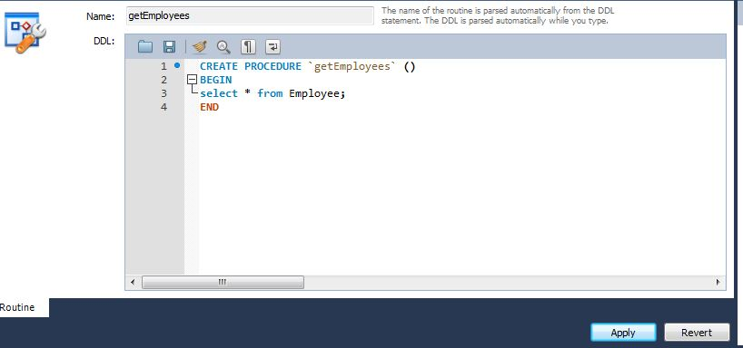

1. Creating Second procedure query

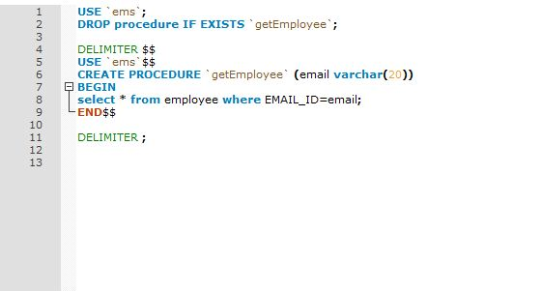

3. Now call your procedure function to test

Calling: first1

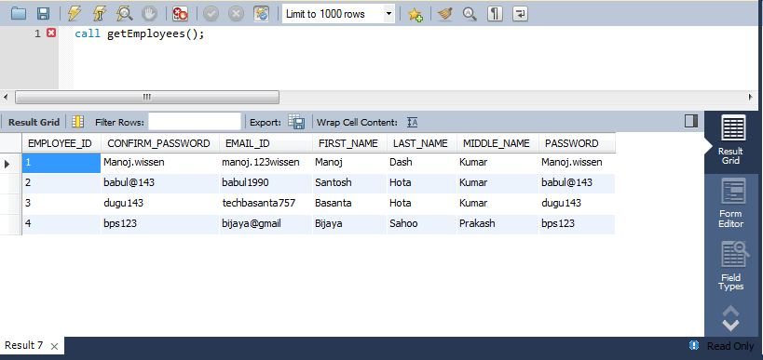

Calling:2

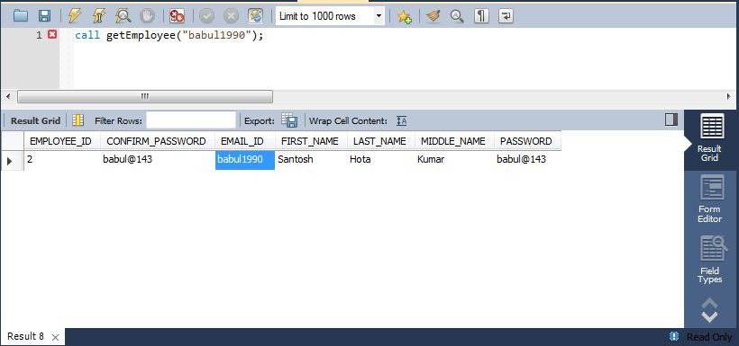

Both procedure is working fine in MYSQL cmnd , so now start development your application